23.32: a) 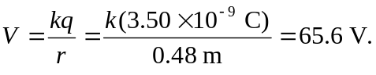
b) 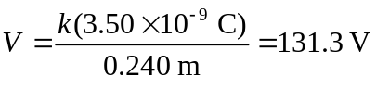
c) Since the sphere is metal, its interior is an equipotential, and so the potential inside is 131.3 V.

